Commercial Units to Let – “Hope Holdings” Camperdown Industrial Estate
A fantastic opportunity to rent one of three versatile commercial units at “Hope Holdings”, Camperdown Industrial Estate, ideal for administrative businesses, beauticians, sports physios, and other professional service providers.
Available Units:
Unit 1: 182 sq ft
Unit 2: 224 sq ft
Unit 3: 476 sq ft – Photos pending.

Key Features:
Flexible spaces suitable for a range of commercial uses.
Some office equipment included, as shown in photos.
Shared kitchenette and communal bathroom facilities.
Dedicated parking available.
Excellent commuting links and easy access.
Exempt from business rates.
Rent available on application.
Whether you’re starting out, expanding, or relocating, these well-located units offer a practical and professional base for your business.
Get in touch today to arrange a viewing or discuss availability.

Unit 1.
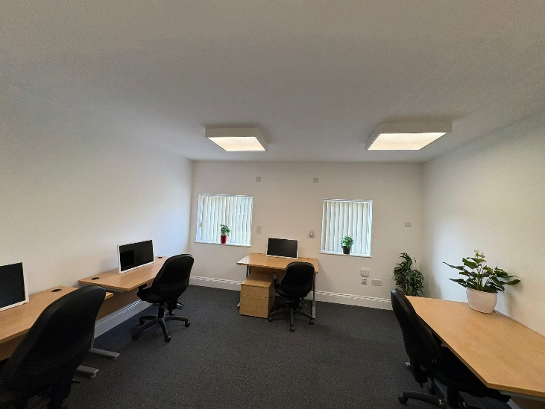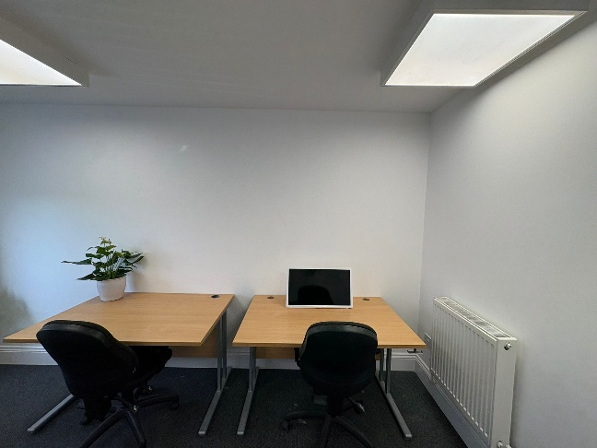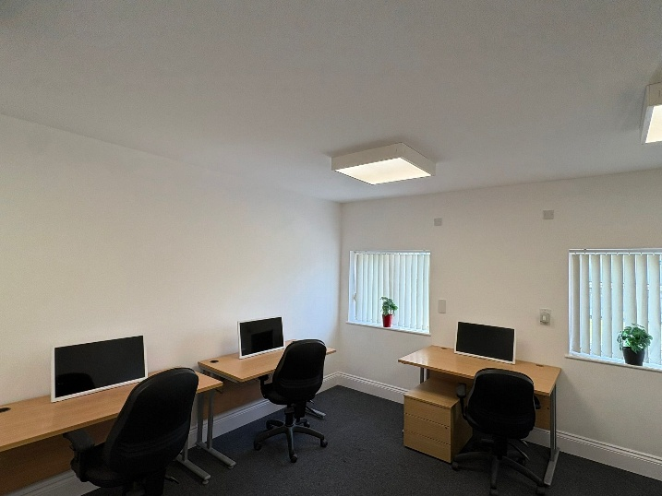
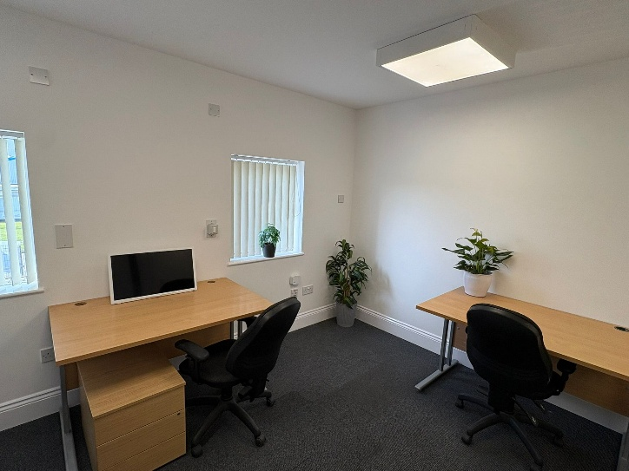

Unit 2

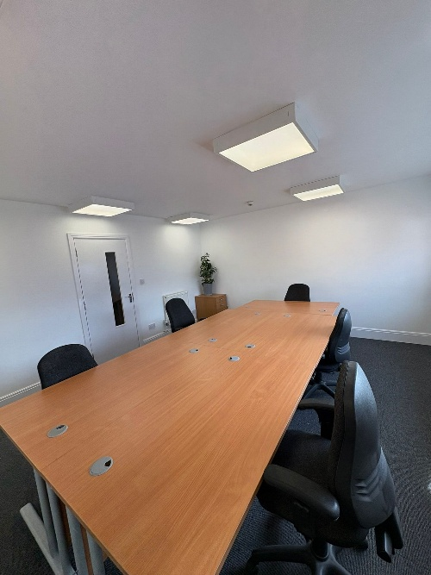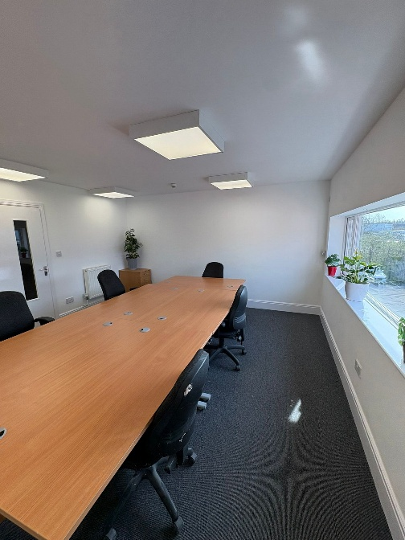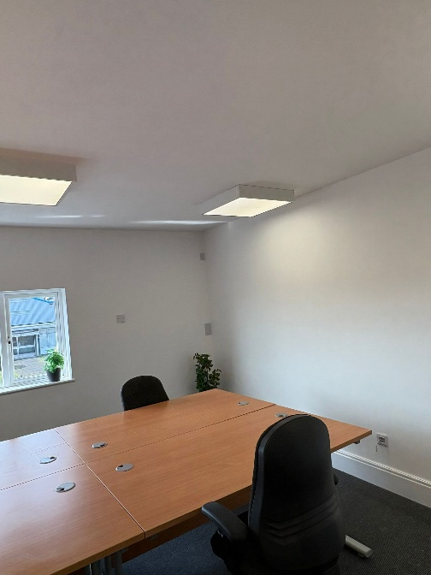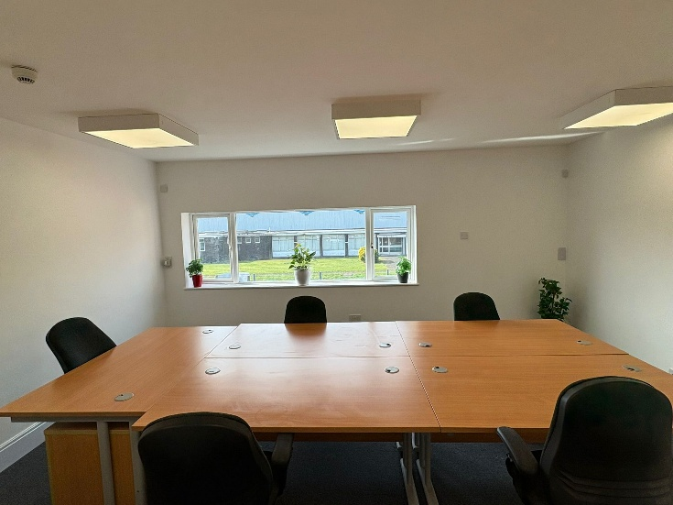
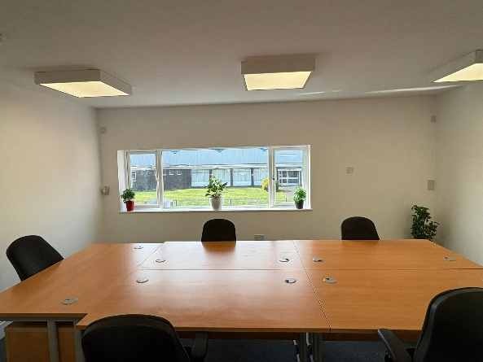

Kitchen

